

MIDDLE EAST TECHNICAL UNIVERSITY

DEPARTMENT OF ELECTRICAL AND ELECTRONICS ENGINEERING

EE463 Static Power Conversion – I

Hardware Project Report

Converting Falcons

28/01/2018

Ayberk Kaan Filik - 2030690

Cem Kavuncu - 2030963

Olgun Erdoğan - 2030567

Table of Contents

1) Introduction 3

2) Projects Description 4

2.1. Problem Description 4

2.2. Possible Solutions 5

2.3. The Solution Approach 6

3) Simulations 6

3.1. AC-DC Diode Bridge Converter 7

3.2. DC-DC Buck Converter and DC Motor 8

3.3. Heat dissipation and Heatsinks 13

4) Experimental Results 13

5) Component selection 17

6) Cost Analysis 18

7) Conclusion 18

8) References 18

1. **Introduction**

Around 40 percent of the world’s power needs are currently met by electrical energy and that proportion is expected to rise as countries cut carbon emissions and shift to renewable energy sources. As the trend towards electrification and renewable energies increases, enabling technologies such as power electronics are becoming ever more important. [1]

Power electronics is an umbrella term that encompasses the systems and products involved in energy processing and controlling the flow of electric energy by supplying voltages and currents in a form that is optimally suited for user loads. Modern power electronic converters are involved in a very broad spectrum of applications like switched-mode power supplies, active power filters, electrical-machine-motion-control, renewable energy conversion systems distributed power generation, flexible AC transmission systems, and vehicular technology, etc. Simply charging a laptop, for example, requires modifying the alternating-current (AC) voltage from the electricity mains to a lower voltage direct current (DC).

The main goals of power electronics are high Efficiency, high power density (i.e. small size), reliable, high quality output (and input) power and minimum cost. The main challenge of these goals is efficiency for two reasons. The first one is that it is desirable to get as much usable energy out of the input as possible, and to limit the heat emission. The more efficient the design is, the less energy it will waste and the less heat-sink it will need, which provides us making smaller devices.

The traditional application area of power electronics is variable speed drives for electrical motors. Power-electronics technologies are able to vary the speed of motor drives, making processes more efficient and reducing the amount of energy consumed.

In this project, our company is required to design a controlled rectifier that will be used to drive a DC Motor. In other words, we are required to obtain an adjustable DC output from three phase or one phase AC input. In this report, a detailed explanation of our design will be included. Firstly, we are going to mention our project description which includes our problem, possible solution and our selected solution approach and the critical parts of our design. Secondly, we are going to mention the simulation results of our design. Also, we will explain the thermal analysis of our design. Then, the experimental (test) results are going to be included. Moreover, our choices for the equipments and the reasons for choices and cost analysis for them will be mentioned. Finally, we will mention the conclusion part for our design report.

1. **Project Description**
   1. **Problem Description**

In this project we are required to make a controlled rectifier that will be used to drive a DC Motor. In other words, our design should take the three or one phase AC as input and turn it into adjustable DC output. The DC motor which we will drive is as follows

[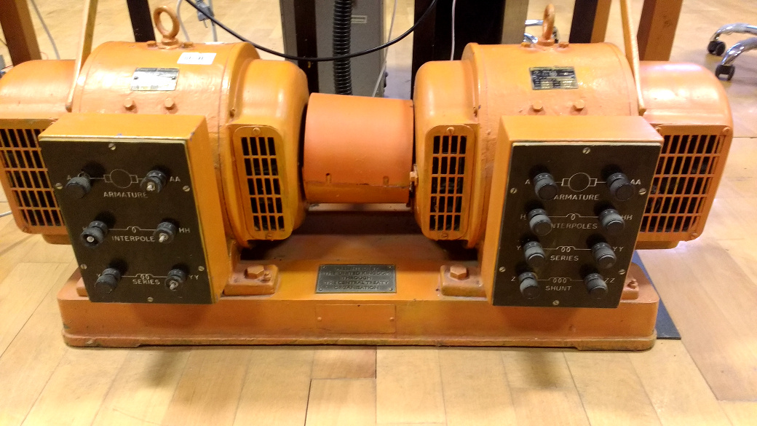](https://github.com/odtu/ee463/blob/master/Hardware-Project/motor-set.jpg)

Figure 1: The DC motor-generator sets

The motor’s parameters can be seen in the Figure 2:

[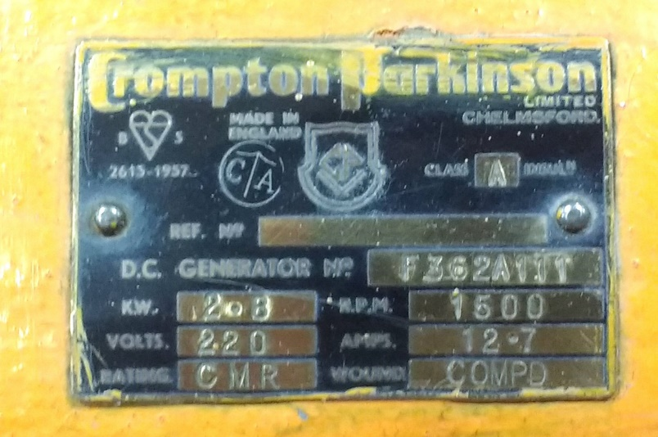](https://github.com/odtu/ee463/blob/master/Hardware-Project/motor-label.jpg)

Figure 2: The motor's parameters

The motor's parameters as follows:

* Armature Winding: 2.8 Ω, 13.3 mH
* Series Winding: 65 mΩ, 260 uH
* Shunt Winding: 8.26 kΩ, 6.4 H
* Interpoles Winding: 0.8 Ω, 5.8 mH
* Inertia: TBA

We are reqiured to start the DC motor from standstill to rated speed under no load (but still we have the inertia, and the friction) and run for 2 minutes. We are allowed to soft start your drive (i.e. for charging capacitors etc) with a variac, but variac should not be used to control the voltage while the motor is running.

* 1. **Possible Solutions**

We are free to choose any topology such as 3-Phase thyristor rectifier, 1-Phase thyristor rectifier, diode rectifier + buck converter. They all have advantages and disadvantages. Firstly, we are going to explain their advantages and disadvantages, then we will mention our choice in detail.

1. **Three Phase Thyristor Rectifier**

Using three phase thyristor rectifier is one way to do AC-DC conversion and control the output. It requires a three phase controlled rectifier, a DC-link capacitor, pulse generator or gate driver circuits for thyristors and heat-sinks.

As Converting Falcons, we decided that the implementation of the gate driver circuits for giving pulses to the thyristors and control them is challenging for us. Therefore, we decided not to use this topology in our design for this project.

1. **One Phase Thyristor Rectifier**

Using one phase thyristor rectifier is another way to do AC-DC conversion and control the output. Similar to the previous one, it requires four thyristors and four gate driver circuits, heatsinks and DC-link capacitor. One problem for using one phase thyristor rectifier is that its output voltage is smaller than the output voltage of three phase thyristor rectifier, this issue may be problem for us to produce the desirable voltage rating.

1. **Three Phase Diode Rectifier + Buck Converter**

Using three phase diode rectifier is another way to do AC-DC conversion. Although its output has more ripple when compared with others, its implementation is easier than the others. It just requires a diode bridge rectifier and heatsink. However, since it does not provide us controlling the output voltage, we need to implement another circuit additionally in order to control the output voltage. Therefore, a buck converter which is a DC-DC converter should be implemented additionally to decrease and control the output. Therefore, for the Buck converter, we need to have a power MOSFET and gate driver circuit for it, also a fast free-wheeling diode, two DC-link capacitors (one for the output of Diode Bridge and one for the output of Buck converter) and controller unit.

* 1. **The Solution Approach**

As Converting Falcons, we discussed the different solution approaches of this project and decided to use the diode bridge rectifier and buck converter solution since it is the easiest one to implement for us. It requires only a single gate driver circuit to control the output voltage rating with producing duty cycle and we are able to decrease the ripple at the output and THD of the current with using this topology. Different from the case with using just thyristors no synchronization or more than one gate driver circuits are needed.

To control the output voltage, we decided to use PWM and produce duty cycle. To produce duty cycle, we chose to use Arduino which is a basic single board microcontroller designed to make applications and interactive controls. We decided to use a power bank to give power to Arduino.

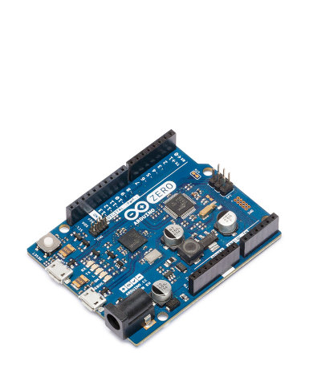

Figure 3: Arduino

Moreover, since we decided to use Arduino, we need to isolate it from the whole circuit because under high voltage it can be damaged. After our researches, we decided to use an optocoupler in order to isolate the high voltage side from the low voltage side. Also, we need a floating DC voltage source for optocoupler. To summarize, we decided to use diode rectifier and buck converter topology with producing duty cycle from Arduino and providing isolation with optocoupler.

1. **Simulations**

The duty cycle is set to 80% through the simulation and circuit schematics and simulation results for diode bridge rectifier, buck converter and DC Motor is provided below.

* 1. **AC-DC Diode Bridge Converter**

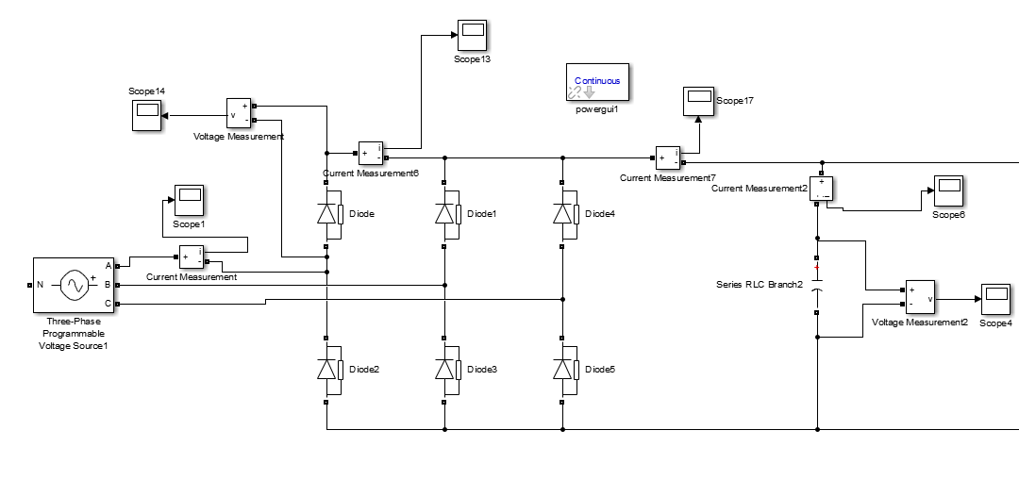

Figure 4: Circuit Schematic of Diode Rectifier

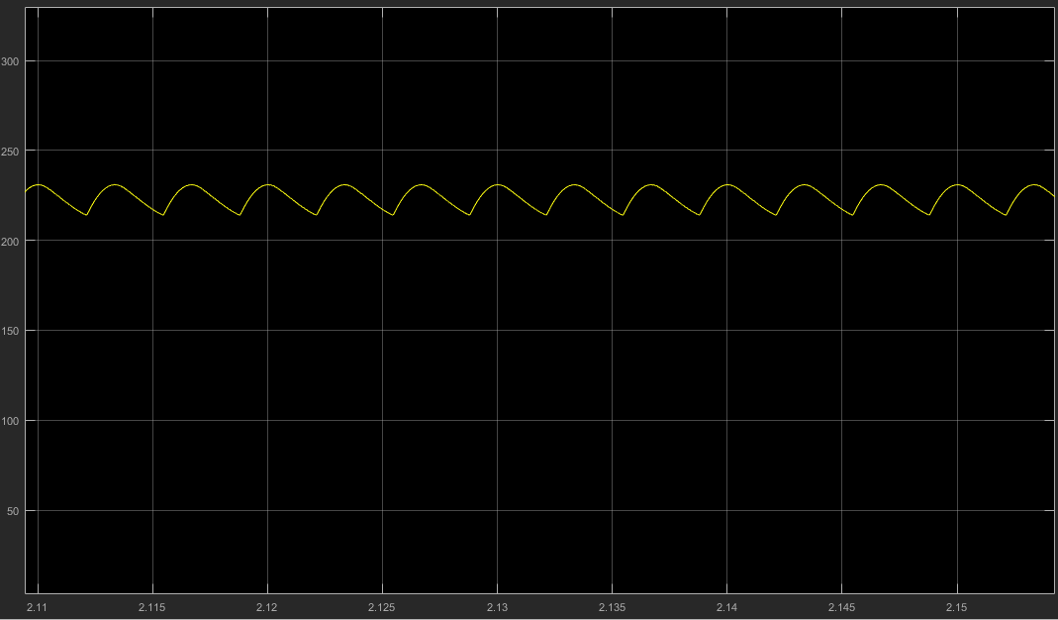

Figure 5: Capacitor Voltage at the Output of Diode Rectifier

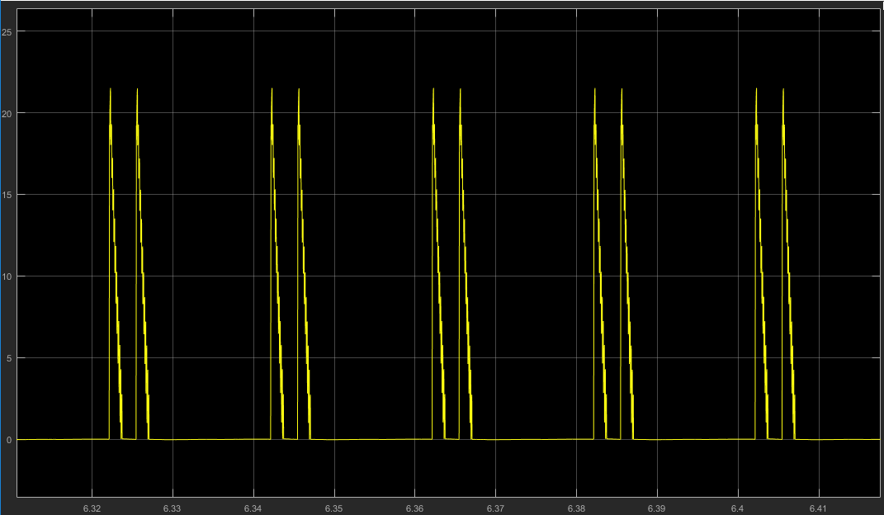

Figure 6: Current over a Diode in the Diode Rectifier

* 1. **DC-DC Buck Converter and DC Motor**

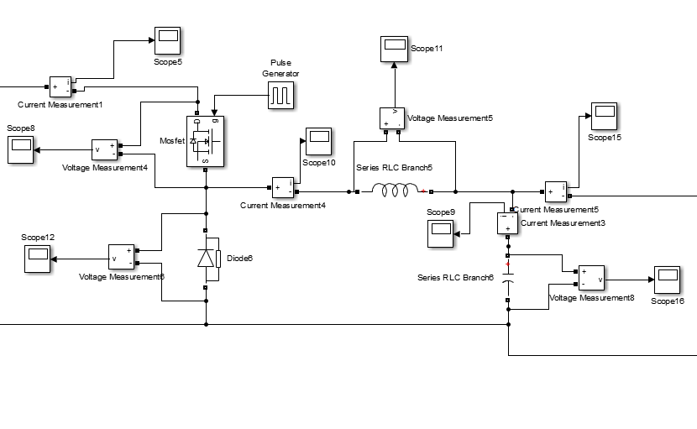  
Figure 7: Circuit Schematic of Buck Converter

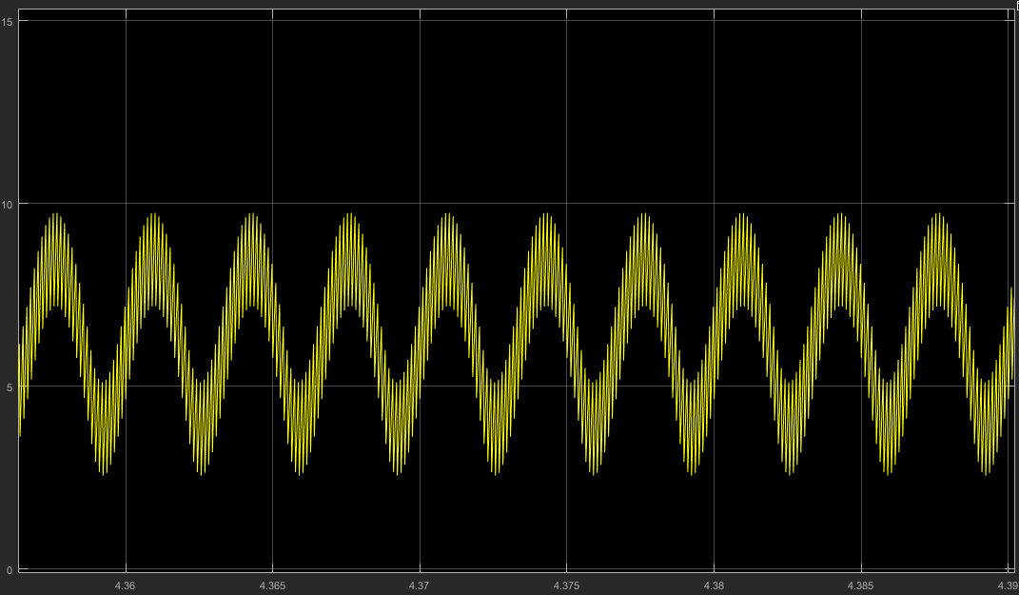

Figure 8: Inductor Current

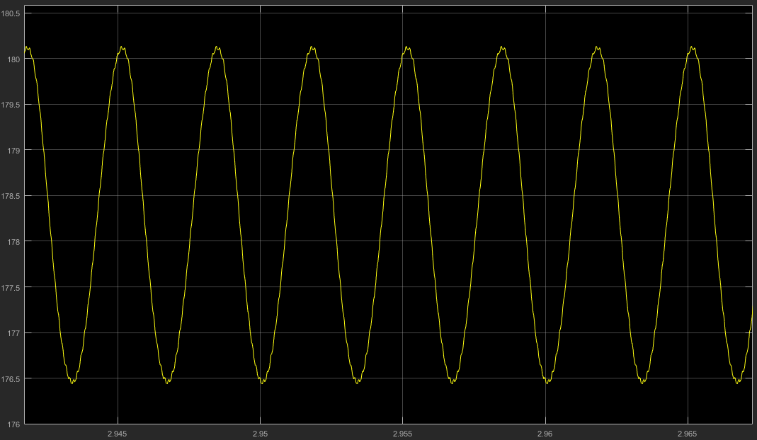

Figure 9: Capacitor Voltage at the Output of Buck Converter

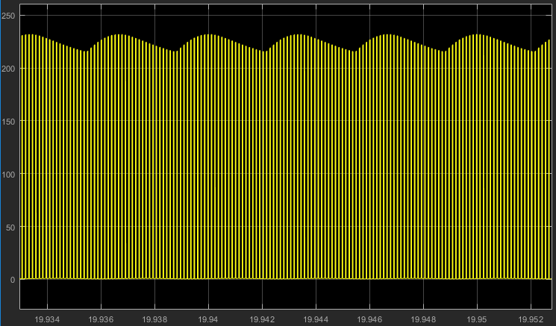

Figure 10: Drain to Source Voltage of the MOSFET

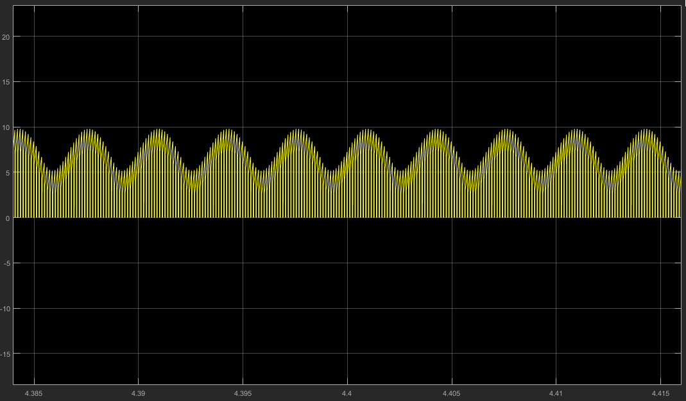

Figure 11: Drain Current of the MOSFET

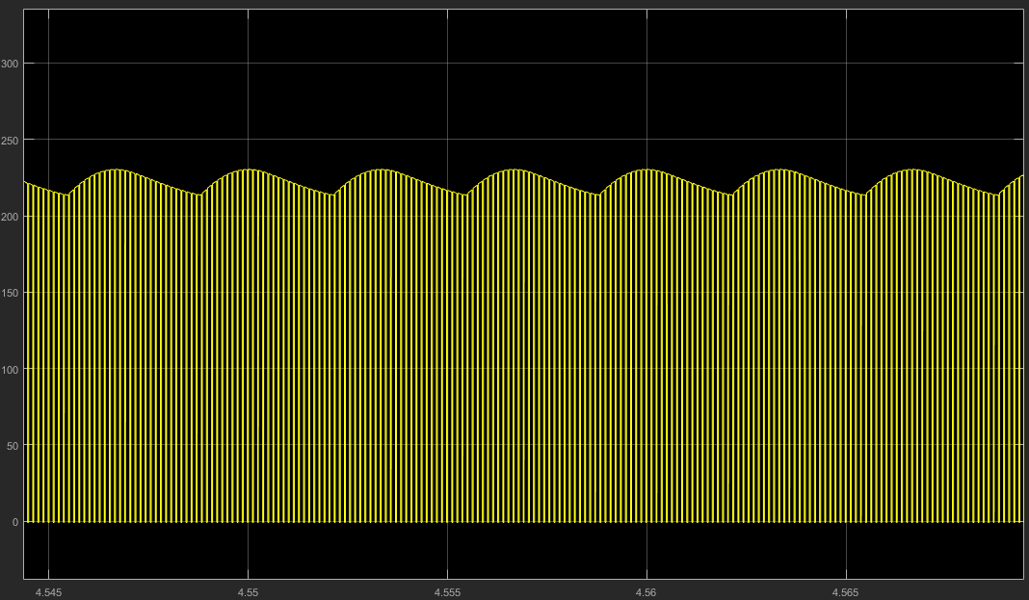

Figure 12: Voltage on the Freewheeling Diode

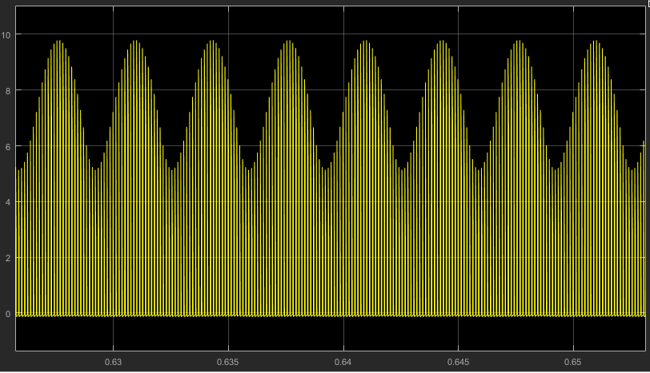

Figure 13: Current of the Freewheeling Diode

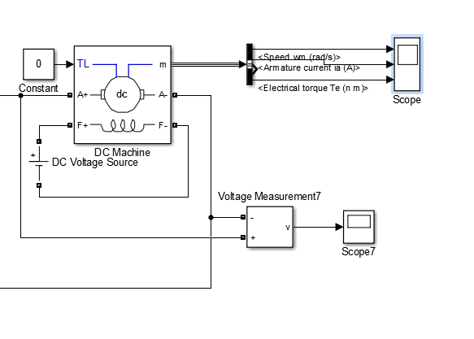

Figure 14: Circuit Schematic of no-load DC Motor as load to the Buck Converter

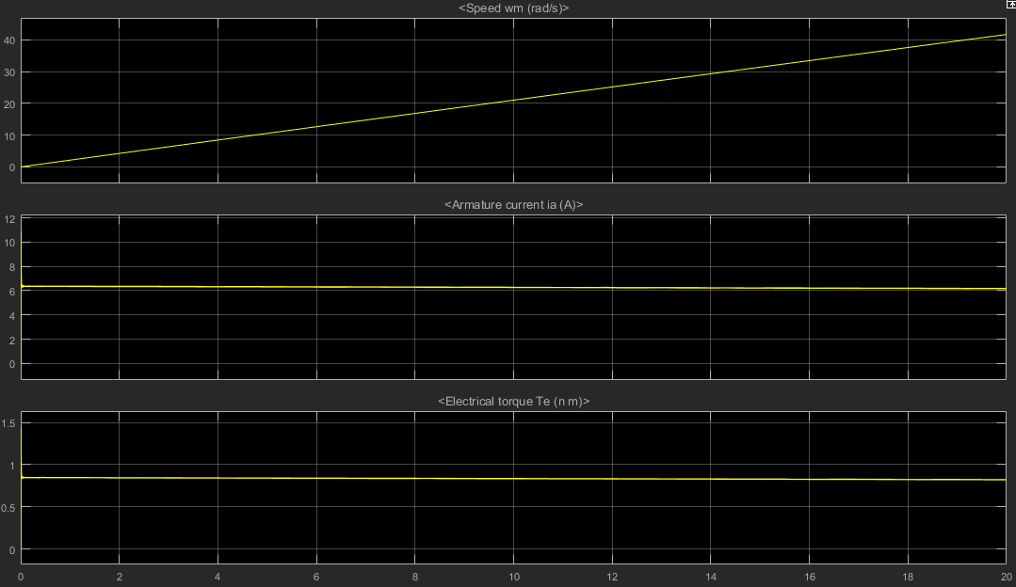

Figure 15: Speed, Armature Current and Electrical Torque of the DC Motor

* 1. **Heat dissipation and Heatsinks**

For heat dissipation on the diode rectifier, it is not provided in datasheet but it is provided that its thermal resistance with heatsink mounted is 1.35 °C/W and since its operating temperature is up to 150 °C, it can dissipate nearly 100 W energy as heat.

The heat dissipation on freewheeling diode is for the worst case. We bought a heatsink observed that diode is not reaching to really high temperatures so we decided experimentally that that heatsink is enough for this operation since we cannot find the datasheet of the heatsink.

The heat dissipation on MOSFET is . We first bought the same heatsink used for freewheeling diode and observed that MOSFET is getting heated so much then we decided to buy a new large heatsink to cool it down. This new heatsink cooled it very well compared to the previous case.

1. **Experimental Results**

After we implement our circuit, we started to do test before connecting our design to DC motor. Our experiments started with using R load. Firstly, we connected R load at the end of our Diode Bridge Rectifier and observed whether it works well or not. As it can be seen from the figures below, we obtained successfully DC voltage from three phase AC grid as expected. We connected 160 Ω as R load.

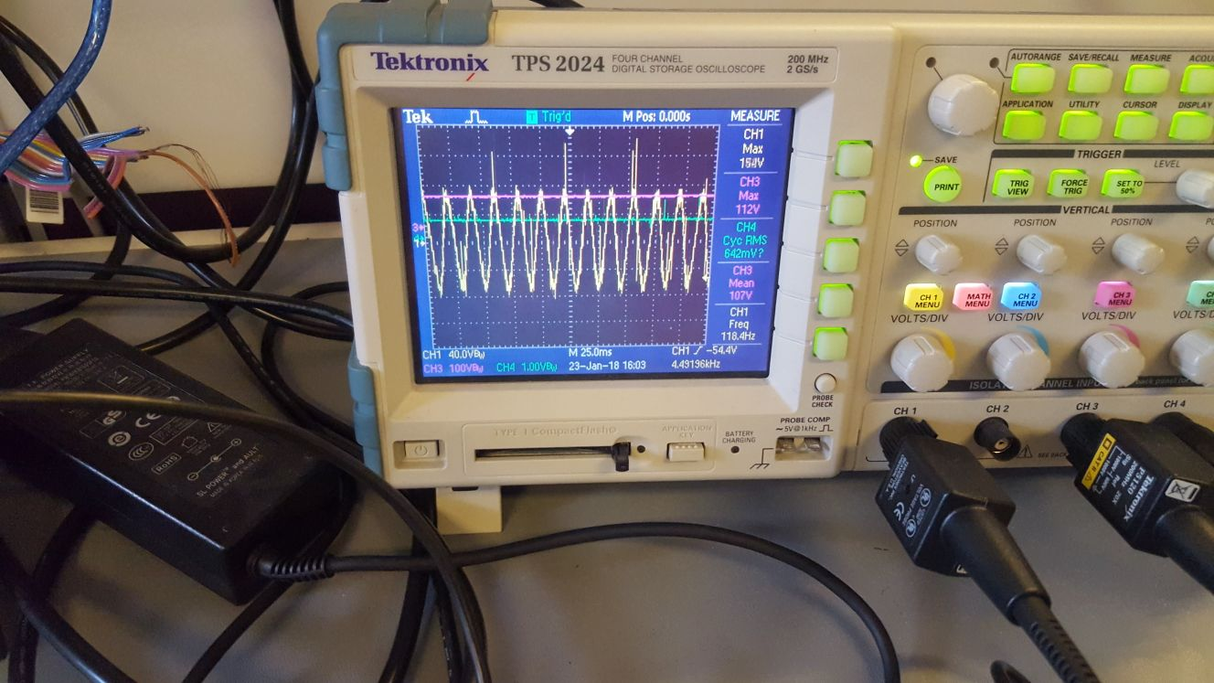

Figure 16: The input and output of Diode Bridge Rectifier

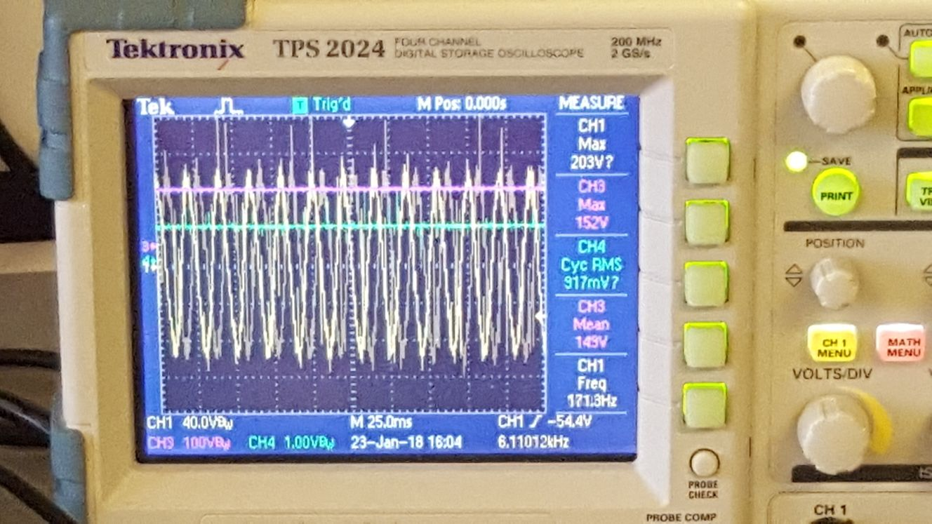

Figure 17: The input and output of Diode Bridge Rectifier

Then we started to implement our buck converter, before testing the buck converter, we implemented our gate drive circuit for MOSFET with using optocoupler and Arduino. The duty cycle that we produced by using Arduino can be seen as follows:

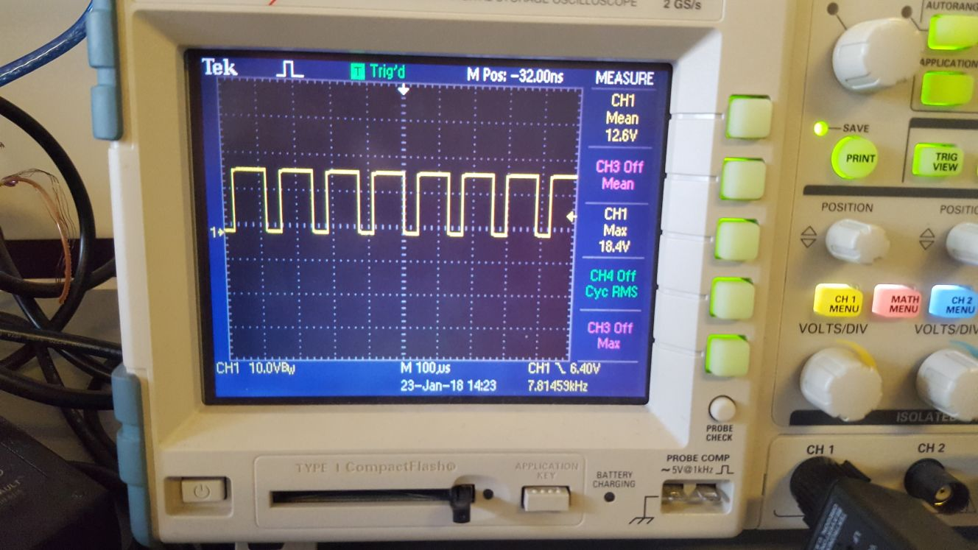

Figure 18: The duty cycle

Also, this voltage waveform will be output of the optocoupler and it is connected with gate of power MOSFET. After producing this duty cycle, we started to test our whole design. Firstly, we connected output of buck converter to the R load with setting the R load as 160 Ω. To obtain 160 Ω, we connected the R load series. When 160 Ω is connected at the output, we did not increase the current after 1.3A since it may damage the R load. The waveforms can be seen below. The output current is inverted.

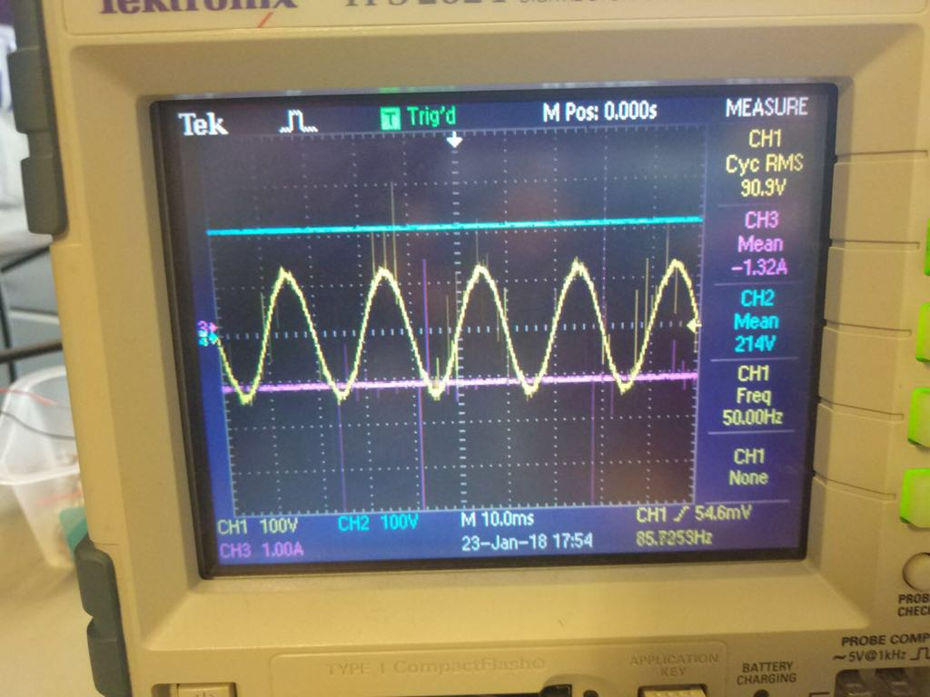

Figure 19: The input and output waveforms for our design

Since we would have high current at the output when our circuit is connected to DC motor, we decided to try to obtain 3A at the output. Therefore, we connected the R load as parallel and obtain approximately 17.67 Ω at the output. We carefully increase the output current to 3A not to harm the R load and obtained the waveforms as below.

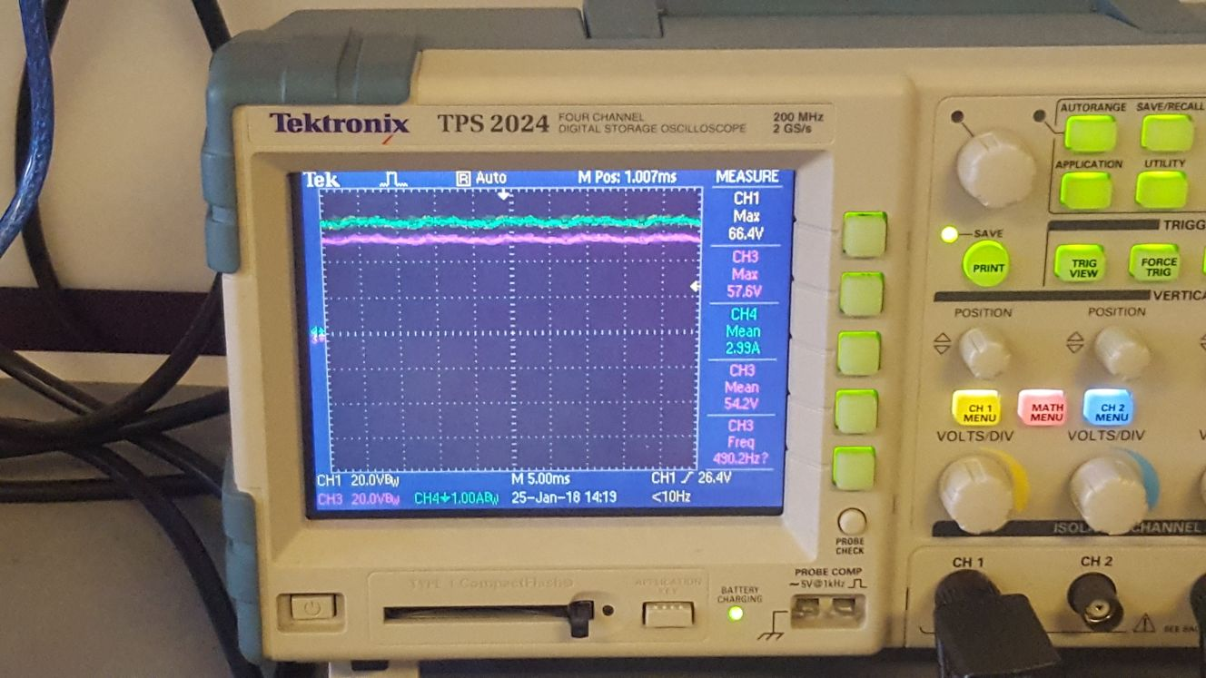

Figure 20: The output voltage and current waveforms

After obtaining the desirable results with R load, we started to work on DC motor. Unfortunately, first time we connected our circuit to DC motor, our oscilloscope had only one scope; therefore, we were able to observe only one waveform at the screen. We selected to observe output waveform and obtained the waveform as follows:

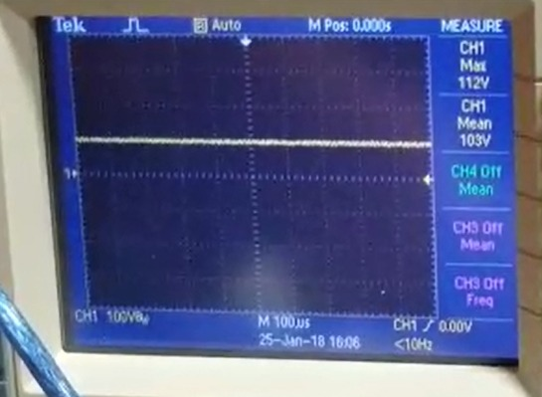

Figure 21: the output voltage waveform when connected to DC motor

After we observed that our circuit managed to drive the DC motor, we tried to increase the output voltage to rated value as 200V and obtained the voltage waveform as follows:

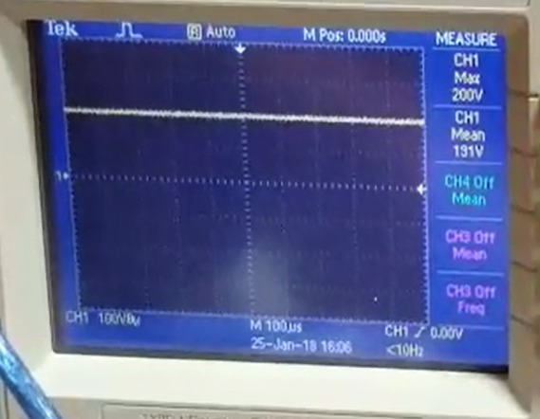

Figure 22: the output voltage waveform when connected to DC motor

After obtaining this waveform at the output, we tried to change the duty cycle with POT and observe the changes at the output. Unfortunately, when we set 0 duty cycle and stop the motor and restarted it, we burned our MOSFET. We changed our MOSFET with the backup one at the demo day. And again, unfortunately, when we were trying to change the duty cycle when driving the DC motor, we burned our MOSFET one more time. Therefore, we were not able to obtain any data about temperature of our components or output current at the output when changing the duty cycle, in other words, changing the speed of DC motor.

1. **Component Selection**

Since the rated voltage and current of the dc motor which we will drive is 220V and 12.7A respectively, we made all of our component selections according to this. The capacitors at the output of diode rectifier and buck converter should be capable of storing at least 220V and the inductor at the output of buck converter should not saturate under and carry 12.7A. We then chose the capacitors as Kendeil K01450681 which has 450V rated voltage and 680µF capacitance. These capacitors are aluminum electrolytic capacitors and they are good at storing voltage but cannot be used for switching purposes. Since we cannot find an inductance with an affordable price to meet our needs, we bought a ferrite core and wrapped it with enameled copper magnet wire and get 1.8 mH in 10 turns.

About choosing switching elements, we had to consider lots of practical issues like voltage and current spikes, inductances of straight lines and the noise created by other components. For example, in ideal case, a MOSFET with 220V and 12.7A rated values is enough for this application but by considering the nonidealities, we chose our MOSFET as IRFP460 which has 500V rated voltage, 20A rated current and nearly 3 MHz maximum switching frequency which is much higher than the switching frequency we are planning to implement.

As mentioned above, we need to store at least 220V on the capacitor at the output of diode rectifier. This means that we need a diode rectifier which can withstand at least 220V and much more current than 12.7A since we use only a capacitor after diode rectifier and in order to follow the voltage on it, the capacitor draws really high current at some points. By considering these needs, we decided to use SKBPC3516 which can withstand 35A and 1600V.

As freewheeling diode, we also need at least 220V repetitive peak reverse voltage and 12.7A average forward current. For this purpose, we decided to use DSEP30-06A with 600V , 30A and 35 ns reverse recovery time.

As mentioned before, for switching the MOSFET, we needed an optocoupler in order to isolate the control signal generated by Arduino from the circuit. Since we need a voltage difference between the gate and source of the MOSFET, we had to use a floating voltage which makes its output higher than its referenced neutral. As an optocoupler, we decided to use TLP250 which 3750 , 15 to 30V output voltage and nearly 1 MHZ maximum switching frequency. Moreover, its small size did let us to mount it really close to the gate of the mosfet in order to reduce the effect of the inductance of the line used to connect them together.

1. **Cost Analysis**

|  |  |  |
| --- | --- | --- |
| **Components** | **Number** | **Cost (TL)** |
| Capacitor K01450681 | 2 | 80 |
| MOSFET IRFP460 | 1 | 12 |
| Pertinaks | 2 | 15 |
| Free-wheeling Diode dsei30-06a | 1 | 15 |
| Heat Sink | 3 | 20 |
| Diode Bridge Rectifier SKBPC3516 | 1 | 55 |
| Arduino | 1 | 20 |
| Inductor core | 1 | 17 |
| Optocoupler | 1 | 5 |
| 1.6mm (7A) cable for Inductor | 2 meters | 12 |
| Cables (10A) for connection | 5 meters | 10 |
| **Total** |  | |

**7. Conclusion**

In this project, our company was required to design a controlled rectifier that is used to drive a DC Motor. In other words, we were required to obtain an adjustable DC output from three phase or one phase AC input. During this process, we encountered a lot of challenges and made a lot of mistakes. The dissipation of heat and controlling the switch parts were the most difficult part for us to decide and implement. We used three phase diode bridge rectifier and buck converter topology to produce and control the DC output voltage. Also, we used optocoupler for gate drive and isolation. We used Arduino for producing duty cycle. Moreover, we learned by experiencing with burning our components that heat dissipation in power electronics circuits can be a big challenge. We learned how to control a power MOSFET with using Arduino and how to dissipate heat with using heatsinks.

To conclude, we had a chance to incorporate all the theoretical things in class into our project and improved our practical skills. Also, the designing of this project allowed us to increase our creativity and encouraged us to become passionate electrical and electronics engineers.

**8. References**

<http://www.abb.com/cawp/seitp202/85b14cadbc1d544bc1257b5b003de5af.aspx>